Sporty Shoes

Phase 3 Project

Vijay Kumar Moka

[vkvk286@gmail.com](mailto:anupriya.sharma.294@gmail.com)

# PROJECT INTRODUCTION:

Sportyshoes e-commerce website for managing products in portal and selling shoes to customers online.

In this document you can see the prototype of product operations for both page Admin and Customer interaction.

## Admin Operations:

* **Admin Login:** which is authorised according to data in the database.
* **Change Password**: Admin needs to enter the old password to authorise.
* **Manage Products:** Add, Delete, Update Products.
* **Manage Customers:** View, Delete and Search Customers.
* **Manage Purchases/Orders:** View, Delete and Search Orders.

## Customer Operations:

* Register
* Login
* Search Products
* Choose quantity and size
* Add Cart
* View Cart
* Pay and Buy Products
* View previous active orders.

# Home Page:

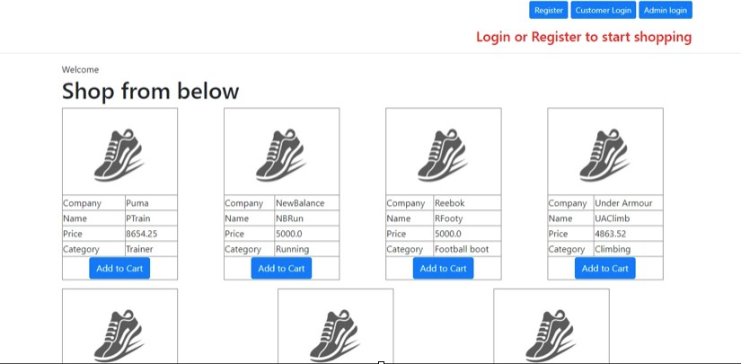

**Customer Interaction:**

Customers need to Login or Register into website to start shopping. If a customer clicks on Add Cart without doing that A prompt will appear until Login or Register.

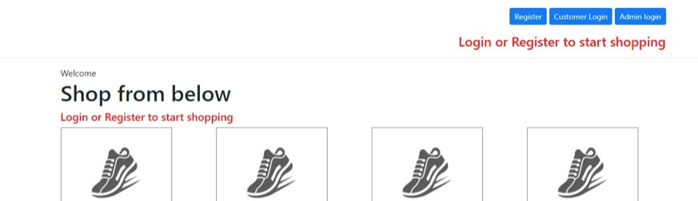

# Customer Registration:

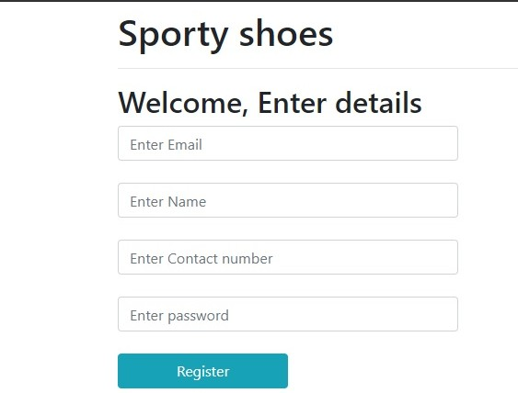

Customer need to enter email in the proper pattern. If not user will not be registered.

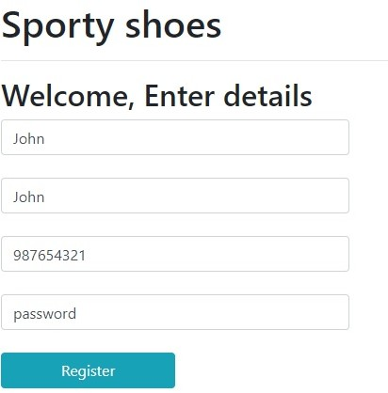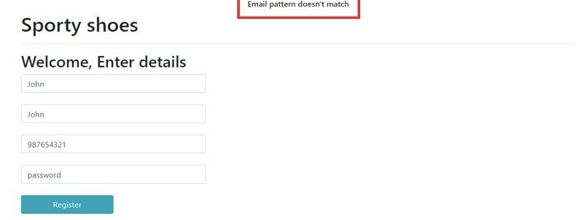

Assume User entered all details properly like below

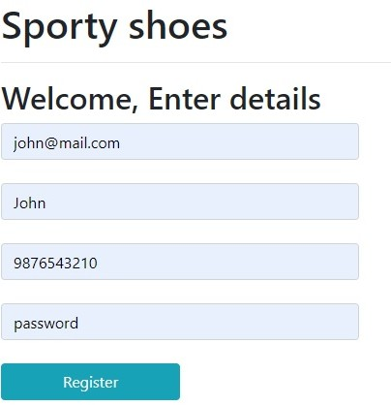

After Successful registration Customer will be logged in straight and ready for shopping

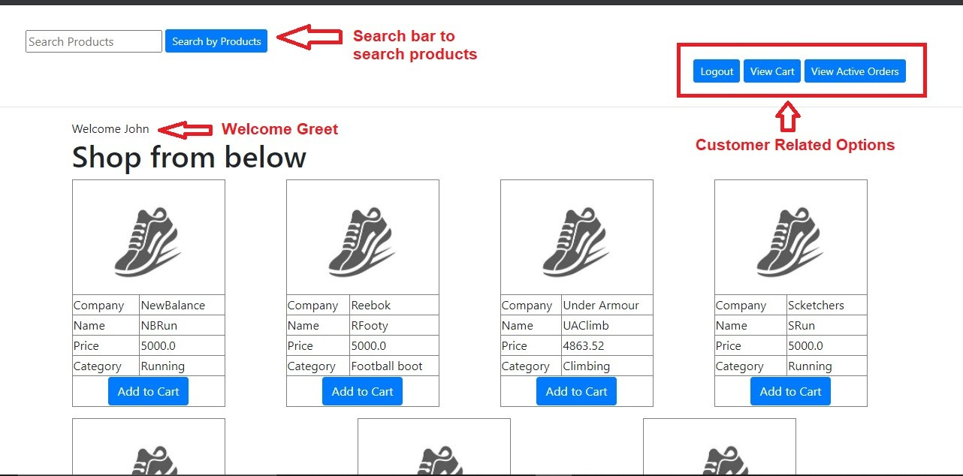

# Customer Login:

Login will also work in the same manner but user just need to enter credentials.

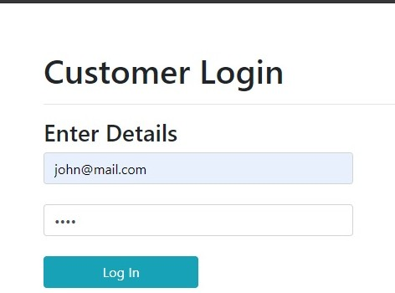

Note: Login will work if user already registered previously.

# Home Page After Login or Register:

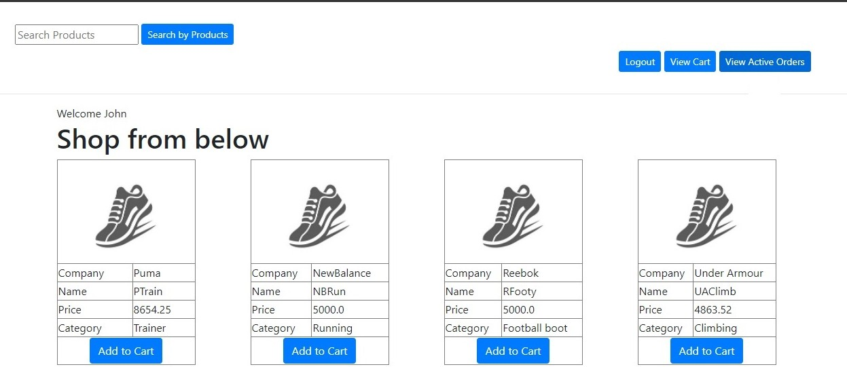

**Search Products:** Customer can Search products

**Logout**: Customer will be logged out and no longer can shop

**View Cart:** Items in cart for current session

**View Active Orders:** Previous active orders are shown by this button.

**Add to Cart:** Customers can add products to cart.

Customer clicks on view cart or View Active orders and If no items found in for the list.

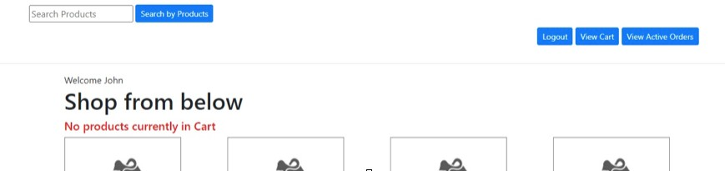

# Search Products:

User can enter any keyword as input to search products:

If any products were not found prompt is displayed showing “Products not found” else products are displayed and ready to shop.

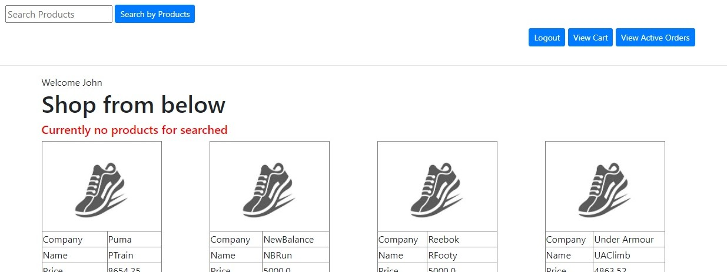

Imagine Customer searching for “run”. So all Running shoes were displayed.

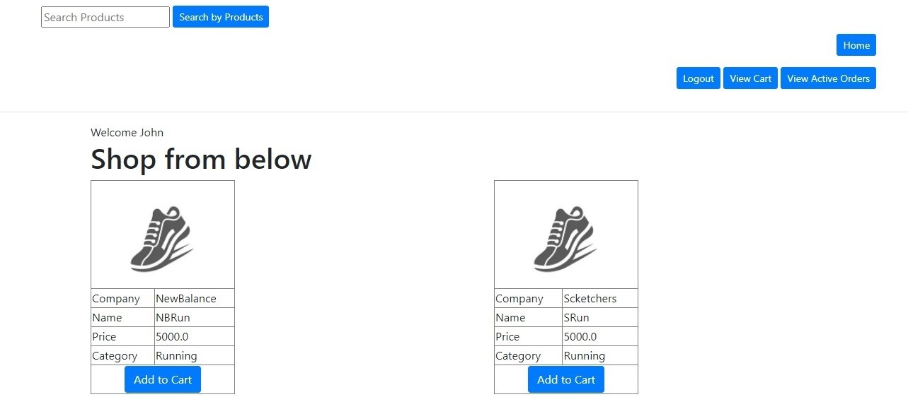

Note: Now a Home button is displayed to go back to home with a full list of products.

# Add Cart:

If user clicks on Add to cart button. A new page is opened and customer needs enter quantity and size of shoes.

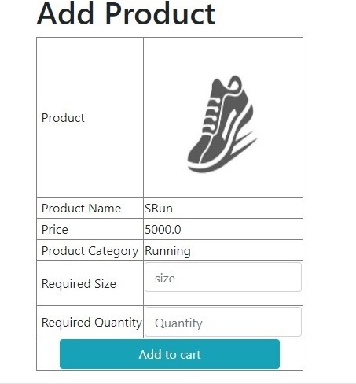

Now User needs to enter size and quantity then click on Add to Cart. then product is added to cart and redirected to homepage

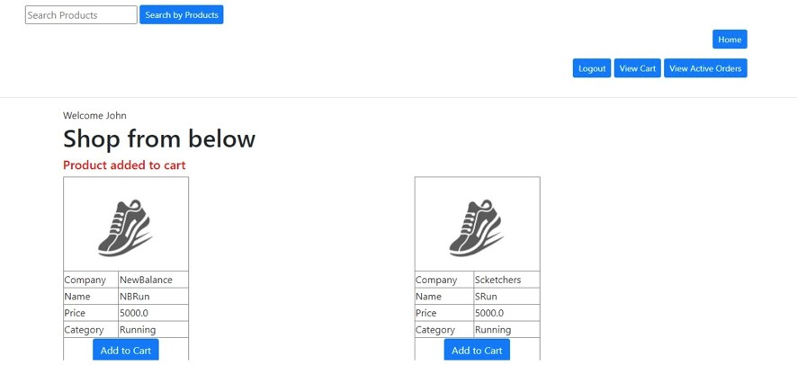

**Note:** until now products are added to cart only, Not yet bought. Now Click on “View cart” to buy products.

# View Cart and Buy Products:

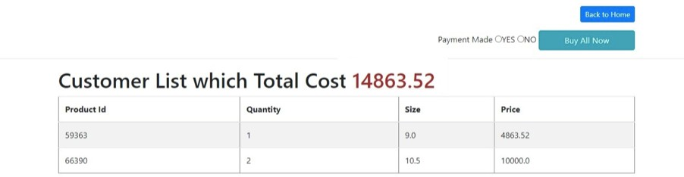

Here a dummy payment mode is added just to demo payment interaction. Customer needs click on “Yes” radio button to finish payment. If customer selects “No” or nothing then error is displayed.

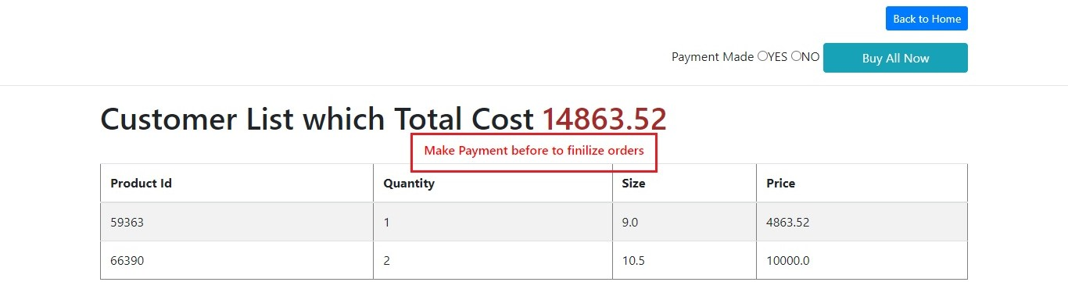

If customer selects on Yes and then click “Buy All Now”. Now products will be added to Purchase list

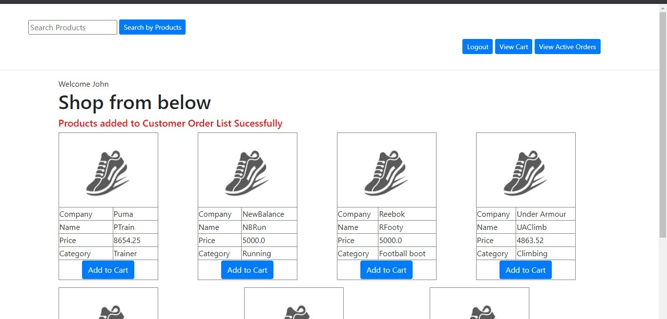

# View Active Orders:

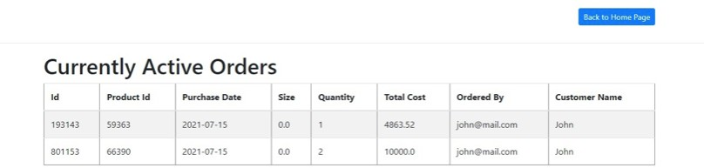

**Admin Login:**

User needs to click on “Admin Login” button to redirect to login page. Admin needs to enter Username and password to login into portal.

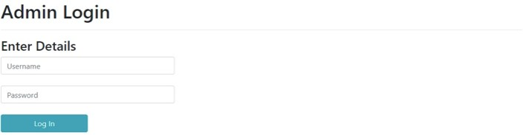

If Admin enter username or password wrong Error message is displayed

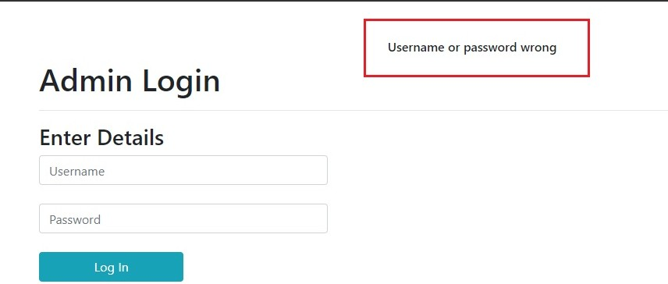

If Admin enters username and password correct then redirected to Admin Dashboard page. Operations in Admin Dashboard are:

* **Change Password:** to change admin password.
* **Log out:** Admin will be logged out.
* **Manage Products**: Add, Update and Delete Products.
* **Manage Customers:** View, Search and Delete Customers.
* **Manage Purchase:** View, Search and Delete Customers.

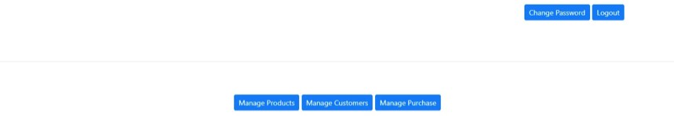

# Change Password:

Here is the screenshot of password change.

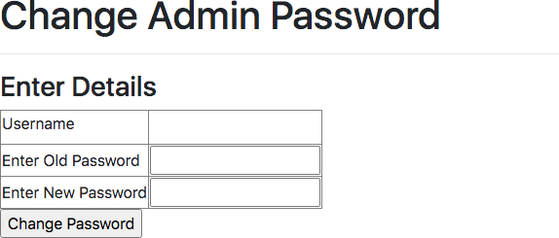

# Manage Products:

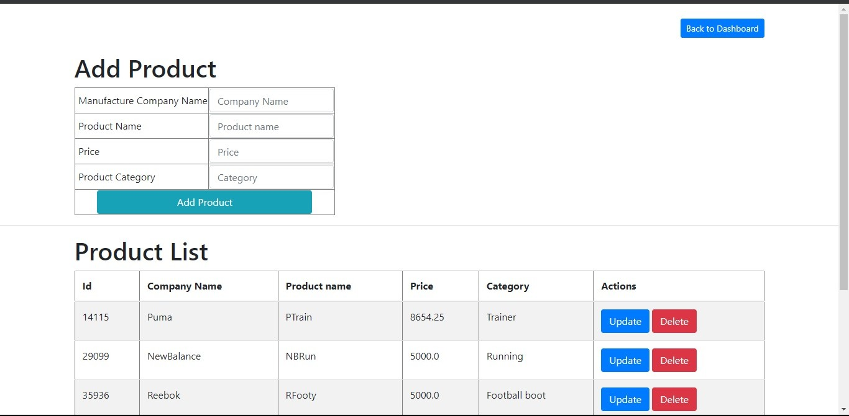

**Add Products:**

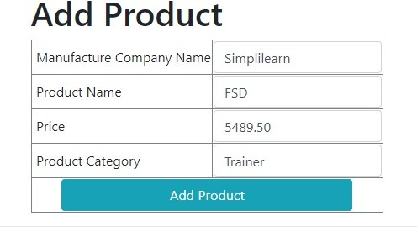

If user clicks on Add products after entering all fields product will be added.

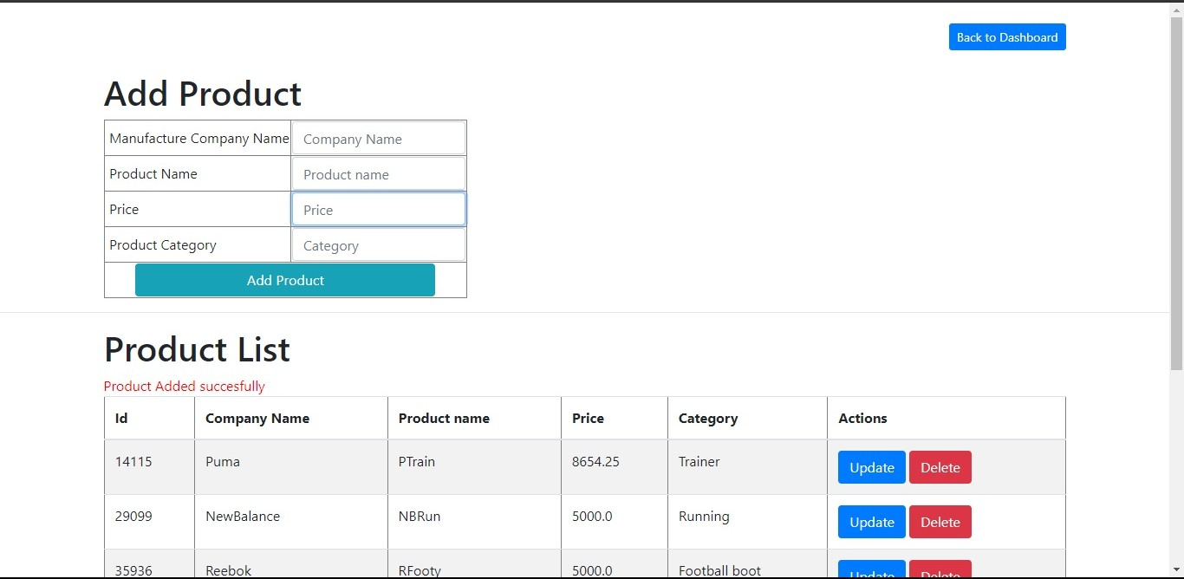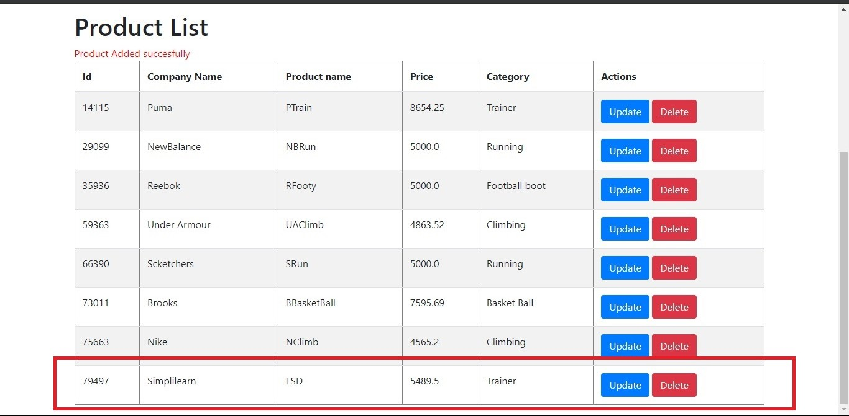

# Update product:

A new page will be opened to enter details.

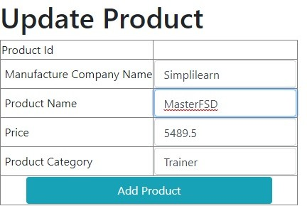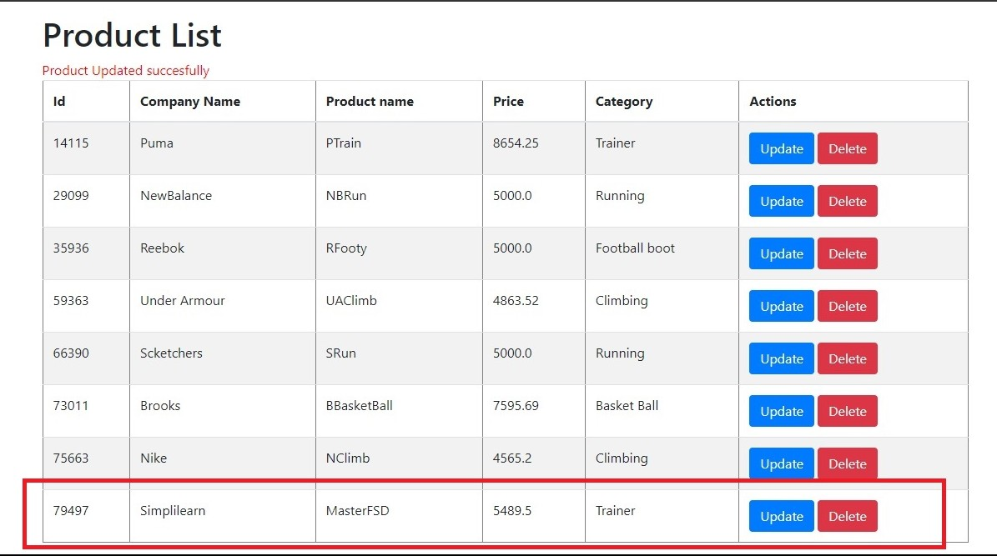

# Delete Product:

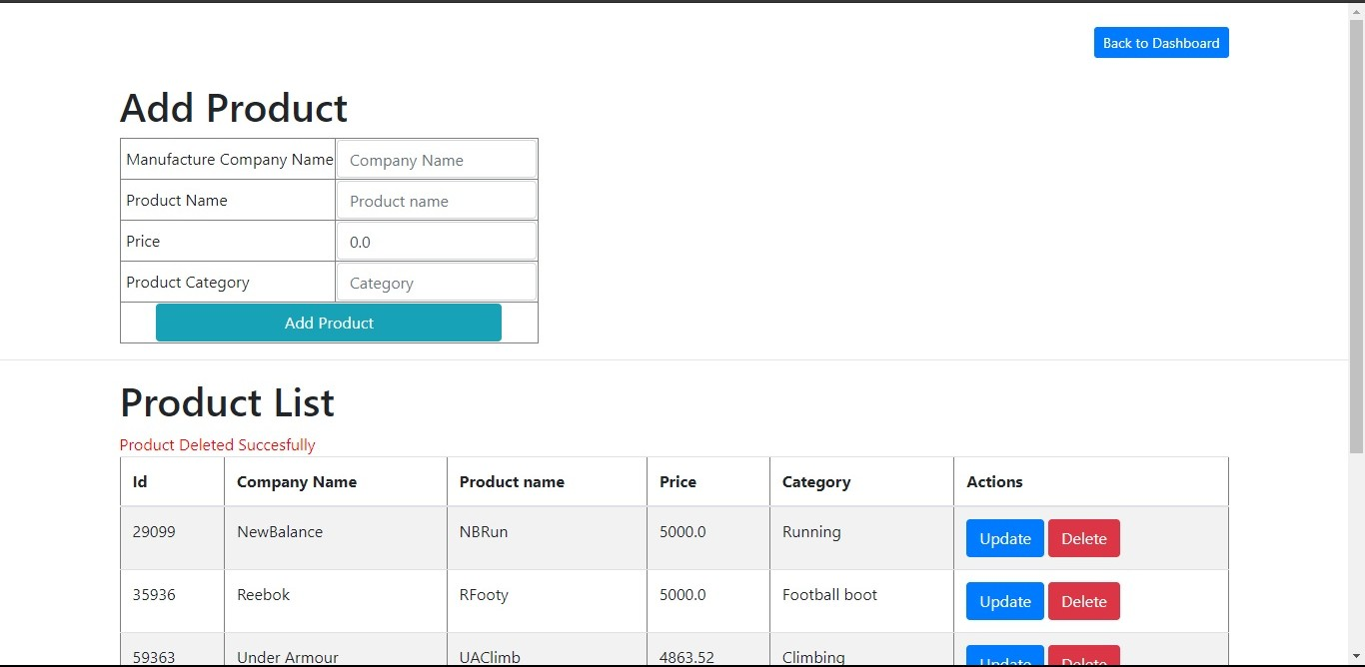

**Manage Customer:**

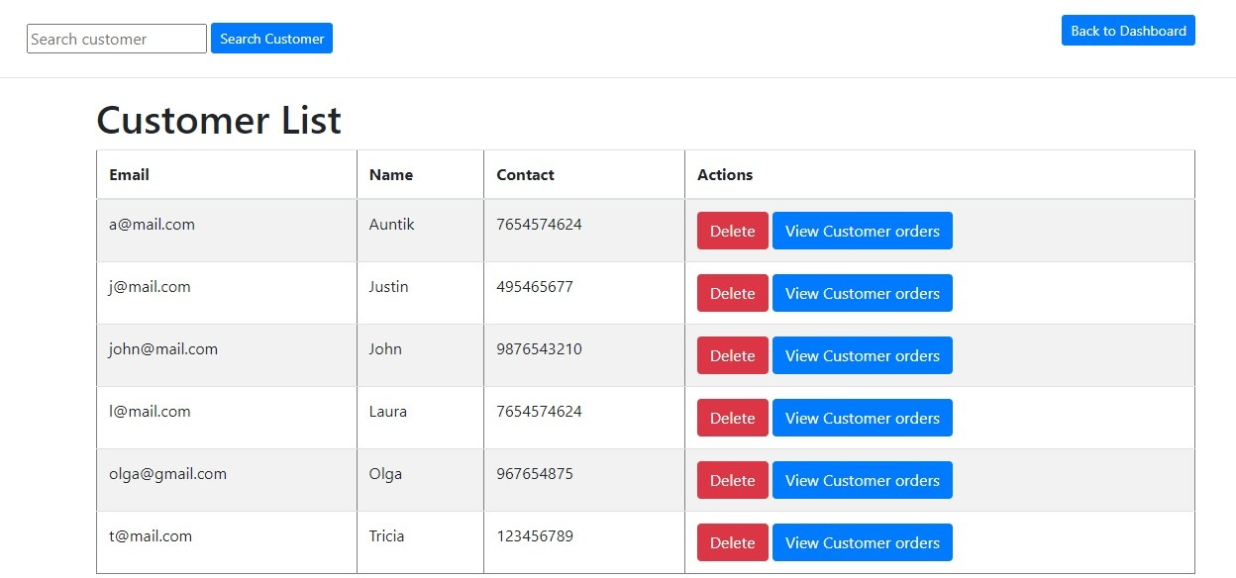

**Search Customer:**

Admin can enter any keyword to search, if nothing found prompt is displayed.

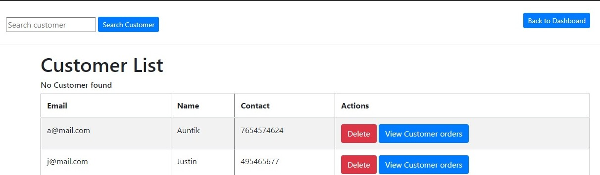

Assume Admin entered “t” and If customers found matching with keyword.

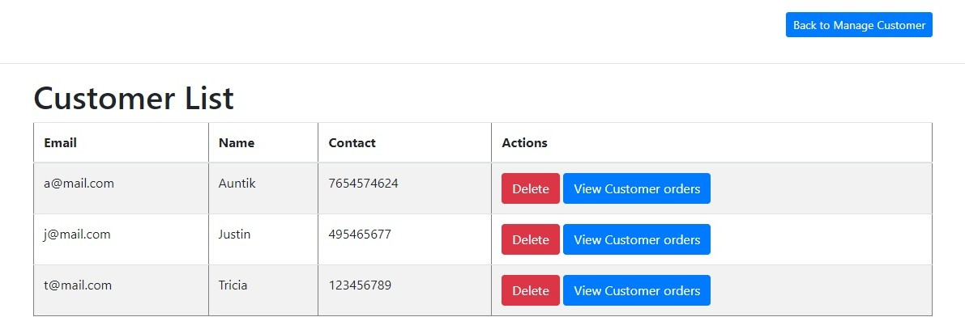

# Delete Customer:

Customer is only deleted if Customer doesn’t have any active orders.

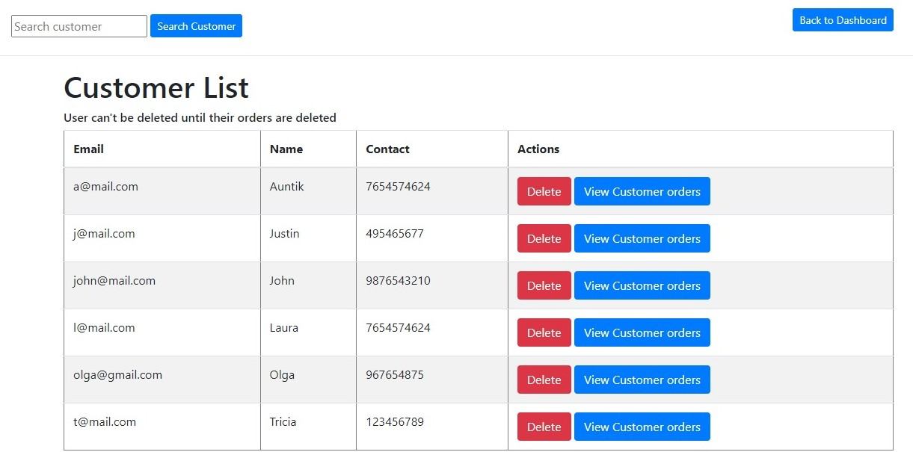

Customer is only deleted if the customer doesn't have any Active Orders.

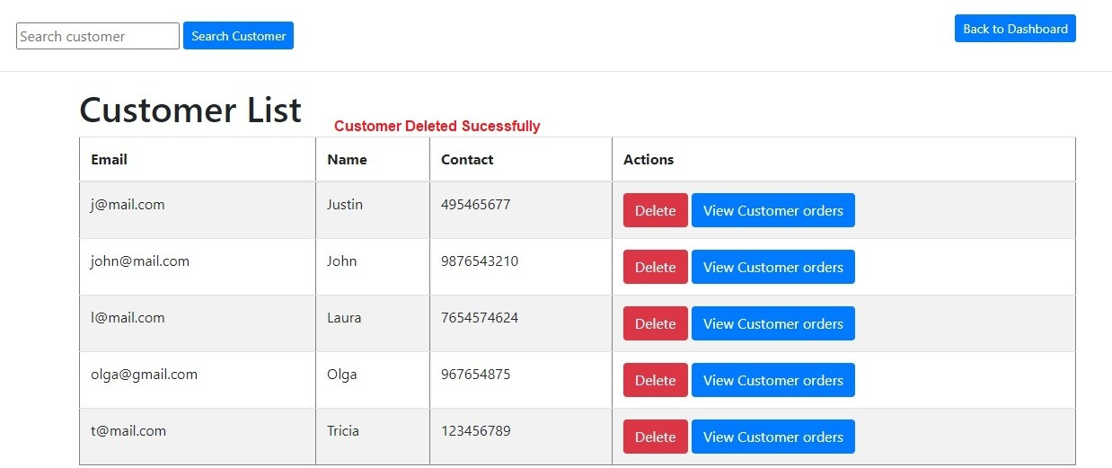

# View Customer Orders:

Customers can view their currently active orders by clicking on “View Customer Orders”.

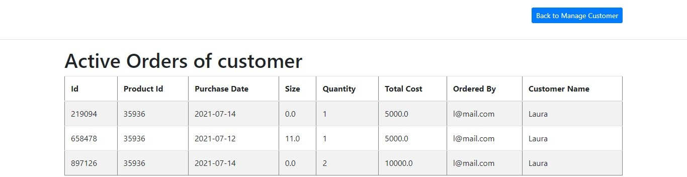

# Manage Purchase:

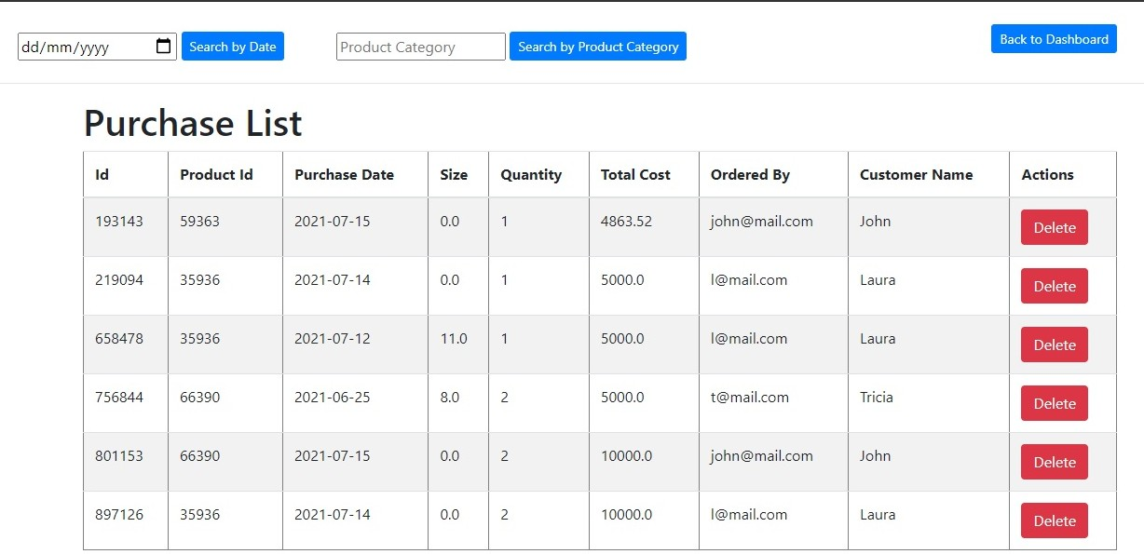

**Search Purchase By Data:**

Admin can select Date to search purchase on certain dates. If no purchases or orders found error is displayed.

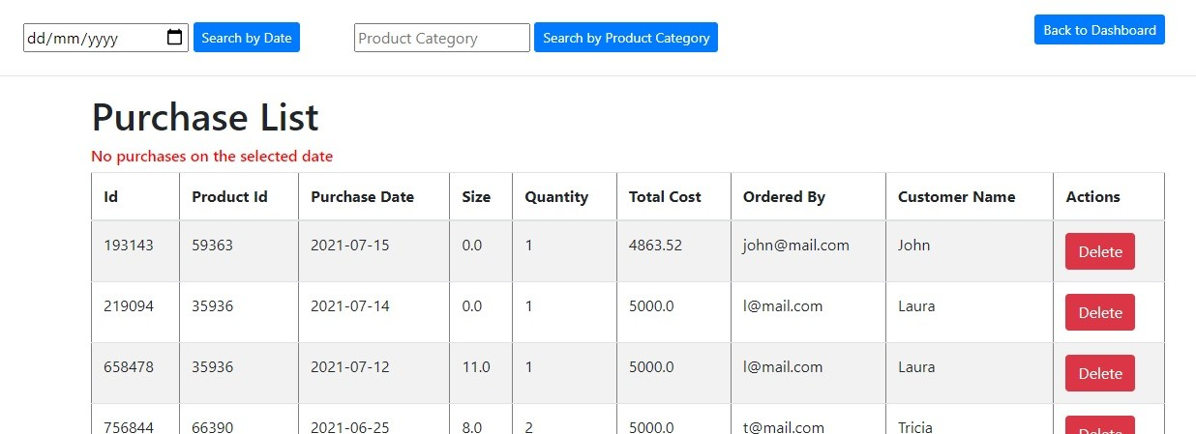

If any purchase found purchases or displayed.

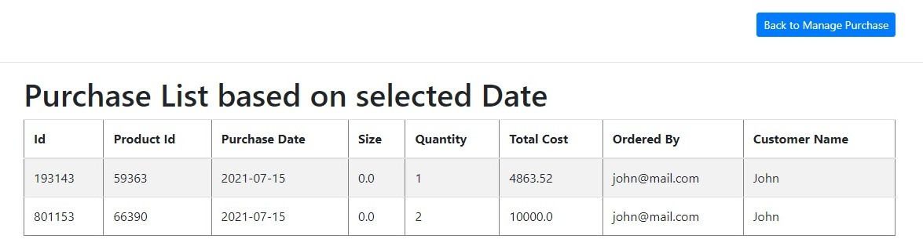

# Search purchase by Product Category:

Purchases are displayed only if category of product matches with keyword. Else “Not found” prompt is displayed. Assume Admin entered keyword “run”.

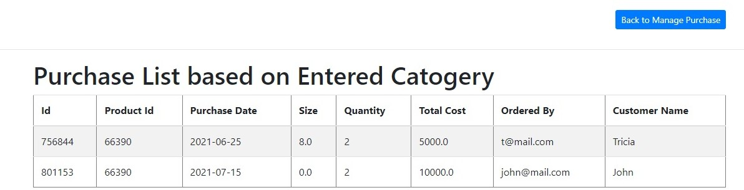

# Delete Purchase:

If Admin clicks on any “Delete” button corresponding purchase is deleted

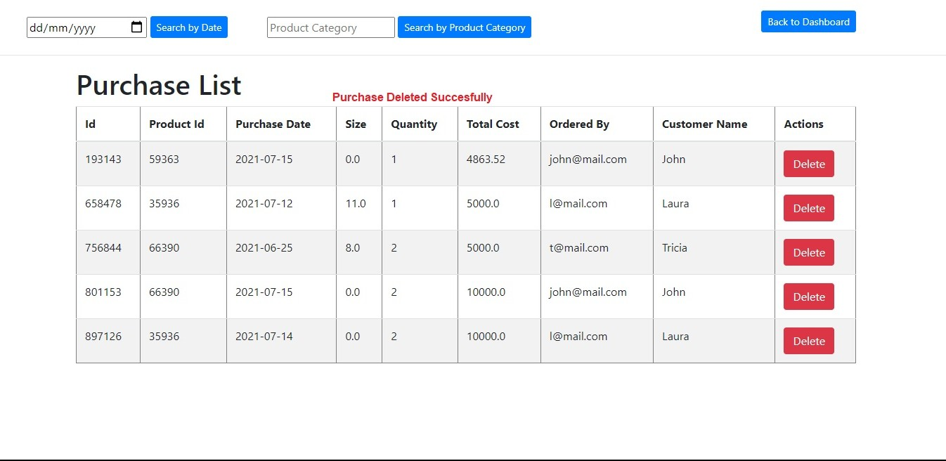

# Conclusion:

By this I hope, I gave a presentation for all the operations. Code for application is given in links at the start of the documents. Execute for clear understanding.

**Thank You**